Post-Project Analysis: Systematic Destabilization of Tigray Through Violent Displacement and Agricultural Destruction

Project Focus and Purpose
This project analyzes the ongoing humanitarian crisis in Tigray through a spatial and contextual analysis of internally displaced individuals (IDPs), food insecurity, medical need, health facility functionality, market functionality, and regional constraints concerning access. Using sub-regional mapping in conjunction with post-conflict reports, the analysis aims to convey how these indicators interact spatially and how they reflect broader patterns of civilian harm, livelihood collapse, and systemic destabilization within Tigray.
The objective of the analysis was not only to visualize humanitarian need but also to interpret how displacement, collapse of basic services, and agricultural destruction operate together as mutually reinforcing mechanisms. The maps were designed to show where stress is concentrated, while the written analysis explains why these patterns exist and how they affect the civilian population over time.
Spatial analysis was conducted in QGIS using zone-level administrative boundaries. Before mapping, datasets were processed in Python using pandas to structure region-level indicators, check for missing values, create derived metrics (including displacement rate per population), and rank regions by severity across food and medical needs and access constraints. Python was also used to generate summary tables and bar-chart visualizations to validate patterns before spatial joins. Cleaned and structured outputs were then joined in QGIS using standardized region/zone identifiers, and graduated symbology was applied to visualize relative intensity rather than absolute precision
AI Statement: AI tools were used for writing feedback, structural guidance, and refinement of language. All data analysis, source selection, interpretation, and conclusions were conducted by the analyst.
II. Internally Displaced Persons (IDPs): Scale, Distribution, and Impact
Data from humanitarian reporting indicates that displacement in Tigray reached unprecedented levels following the outbreak of conflict. “By May 2021, the number of internally displaced persons in Tigray had reached approximately 1.9 million, and by the end of 2021, displacement had doubled to an estimated 4.2 million people due to the ongoing conflict.” (GEOGLAM Crop Monitor – Conflict and Food Insecurity Report (2022)). These figures represent displacement occurring largely within Tigray itself, rather than cross-border movement, reflecting the severity and geographic and systematic entrapment of the crisis.
The IDP concentration map visualizes the uneven displacement distribution across Tigray, with higher concentrations in western and central zones. In QGIS, this is represented through zone-level graduation showing higher IDP concentration in western and central zones, aligning spatially with areas of restricted access and service disruption. Understanding these critical spatial patterns reveals that displacement acts as a dual force: a direct humanitarian outcome and a primary driver of further instability. “Large-scale displacement has significantly disrupted livelihoods and agricultural activities, as households fled rural areas and abandoned productive assets, contributing to increased pressure on host communities and local systems.” (GEOGLAM Crop Monitor – Conflict Reports), which creates immense strain on already weakened health systems.
Displacement in Tigray must be understood as both a cause and a consequence of broader systemic collapse. As households are forcibly removed from their land and homes or flee violence by invading forces, they abandon farmland, livestock, tools, and stored harvests. Over time, prolonged displacement erodes coping capacity, increases dependency on aid, and reduces the ability of communities to recover even if active hostilities were to subside. “Displacement has resulted in widespread abandonment of farmland, loss of livestock and tools, and a reduction in household coping capacity, limiting the ability of affected populations to recover even when active fighting subsides.”
(GEOGLAM Crop Monitor – Conflict Reports).

III. Agricultural Sector Destabilization in Tigray
Agriculture has historically been the backbone of livelihoods in Tigray. “The majority of households in Tigray depend on rainfed subsistence agriculture and livestock production as their primary source of food and income.” (GEOGLAM Crop Monitor – Ethiopia Context Sections). Conflict-related disruption to this sector, therefore, has consequences that extend far beyond immediate food shortages, affecting long-term economic survival and social stability for the broader region.
Reports document that agricultural production in Tigray was not only disrupted by fighting but also systematically undermined through a combination of forced displacement, restrictions on movement, and direct attacks on farming systems. Farmers were reportedly prevented from plowing or harvesting, while crops were looted, burned, or left to rot in fields due to insecurity and labor loss. According to a report from a Crop Monitor Conflict Report, they stated, “Additionally, in a June 2021 news report, farmers, aid workers, and local officials noted that farmers had been stopped from ploughing or harvesting, seeds for planting had been stolen, farm equipment had been looted, and livestock had been killed. Another report noted direct instances of crop pillaging and burning. Women and children were also reported to have worked the lands during the daytime, while adult men remaining in the rural villages worked at night to avoid being a target.” (GEOGLAM Crop Monitor – Conflict Report, June 2021 references).

The destruction extended to agricultural inputs and infrastructure. Seed stores, tools, irrigation equipment, and fertilizer supplies were reportedly looted or destroyed, while agricultural service outlets and warehouses were vandalized or shut down. This resulted in the collapse of local seed systems and input markets, leaving farmers unable to resume production even in areas where fighting temporarily subsided. “Agricultural services and input supply systems were severely disrupted as warehouses and service outlets were vandalized or closed, resulting in limited availability of seeds, fertilizer, and other essential inputs.” (GEOGLAM Crop Monitor – Conflict Reports)
Livestock losses further compounded the agricultural collapse. Reports describe widespread killing or theft of cattle, oxen, and small ruminants, which are essential not only for food but also for plowing and income generation. The loss of oxen in particular severely limited households’ ability to cultivate land, locking many farmers out of future planting seasons. “Widespread loss of livestock, including plough oxen, significantly constrained households’ ability to cultivate land and reduced agricultural production across multiple seasons.” (GEOGLAM Crop Monitor – Conflict Reports)
These patterns indicate that agricultural harm in Tigray was not limited to incidental damage from conflict but followed repeated, overlapping pathways that stripped communities of productive capacity. When fields are abandoned, inputs destroyed, livestock removed, and labor displaced simultaneously, the result is a sustained inability to produce food rather than a temporary shock. “The repeated destruction of crops, livestock, agricultural inputs, and services has had a cumulative impact on production capacity, indicating sustained damage rather than temporary disruption.” (GEOGLAM Crop Monitor – Conflict Reports).

IV. Market Functionality and Economic Strain
The functional markets layer illustrates that while some markets in Tigray remained operational, market functionality varied significantly by zone. Importantly, market functionality does not imply affordability or food security; rather, it indicates the physical presence of exchange activity under constrained conditions.
Agricultural collapse reduced supply even in zones where markets continued to function; households faced severe limitations due to loss of income, high prices, and restricted movement. It is vital to be able to understand the situation on the ground. “The presence of functioning markets does not necessarily translate into food access for households, as loss of income, high prices, and movement restrictions continue to limit purchasing power.” (GEOGLAM Crop Monitor – Conflict Reports).
Markets also became sites of strain as “Concentrations of displaced populations increased demand in certain locations without corresponding increases in supply, intensifying competition for food and basic goods.” (GEOGLAM Crop Monitor – Conflict Reports), further marginalizing displaced households and host communities alike. These economic constraints further compounded medical vulnerability, as households faced reduced access to both food and health services simultaneously.
V. Health System Disruption and Medical Need
The medical need and health facility functionality layers show significant overlap with areas of high displacement and access constraints. Health facilities in many parts of Tigray were reported to be looted, damaged, or rendered non-operational. “Health facilities across Ethiopia’s Tigray region have been looted, vandalized, and destroyed in a deliberate and widespread attack on health care.” (Doctors Without Borders / Médecins Sans Frontières, 2021). These patterns indicate coordinated and repeated attacks on civilian infrastructure rather than incidental damage. “Civilian structures in towns in Tigray, including hospitals, schools, factories, and businesses, were shelled, looted, and destroyed by Ethiopian federal forces and regional militias, and by Eritrean armed forces.” (Human Rights Watch, 2023) These actions display patterns of destruction that reach beyond incidental damage and form part of a broader assault on civilian infrastructure essential for survival.
[P15]
As displacement increased and agricultural livelihoods collapsed, medical needs rose sharply. “The two-year Tigray conflict, characterized by extreme violence, widespread looting, and massive displacement, resulted in the near-total collapse of the health care system. Health facilities lacked medical supplies, biomedical equipment, and health workers, and what health workers were available were often unpaid.” (Doctors Without Borders / MSF, 2023) Malnutrition, untreated chronic illness, maternal health complications, and trauma-related injuries placed additional strain on a health system already functioning at reduced capacity. This collapse extended beyond infrastructure loss to the targeting of humanitarian personnel. An internal review by Médecins Sans Frontières concluded that three clearly identified MSF staff members were intentionally killed in Tigray on 24 June 2021, despite being visibly marked as aid workers, leading MSF to suspend activities and signaling a breakdown of protection for neutral humanitarian actors (Doctors Without Borders / MSF internal review). The targeting of humanitarian personnel not only resulted in loss of life but also accelerated the withdrawal and suspension of medical operations, deepening gaps in care for civilian populations. The killing of humanitarian personnel directly affected the operational capacity of health and aid systems, making it a critical spatial and functional variable rather than an isolated security incident.
Access constraints further exacerbated this crisis. Even where facilities technically existed, road insecurity, restrictions, and fuel shortages limited both civilian access to care and the ability of humanitarian actors to deliver medical supplies. The result was a widening gap between medical need and available services. Violence against humanitarian workers further eroded medical capacity and access. MSF documented that its staff were not killed in crossfire but were deliberately targeted while clearly identifiable, reinforcing an environment in which humanitarian actors could not safely operate. “Of 106 health facilities visited by MSF teams between mid-December 2020 and early March 2021, nearly 73 percent had been looted, and more than 30 percent had been damaged; 87 percent were no longer functioning or fully functioning.” (Doctors Without Borders / MSF assessment, 2021) Together, the destruction of facilities, targeting of health workers, and restrictions on movement created conditions in which both civilian survival systems and humanitarian response mechanisms were rendered ineffective.

VI. Systematic Destabilization and Civilian Impact
Taken together, the spatial patterns across IDP concentration, agricultural collapse, market disruption, health system failure, and access constraints suggest a process of systematic destabilization involving widespread civilian harm, including acts that humanitarian and human-rights organizations have documented as extrajudicial violence, rather than isolated humanitarian shocks. These mechanisms interact in ways that compound civilian suffering and undermine the foundations of survival. This interpretation is supported by documented patterns of civilian infrastructure destruction, in which “civilian structures in towns in Tigray, including hospitals, schools, factories, and businesses, were shelled, looted, and destroyed by Ethiopian federal forces and regional militias, and by Eritrean armed forces” (Human Rights Watch, 2023). These repeated patterns across sectors and regions demonstrate consistency in impact over time, a defining characteristic of systematic harm rather than sporadic conflict damage.
The destruction of agriculture removes food and income, displacement removes labor and stability, market disruption removes purchasing power, and health system collapse removes the ability to survive illness and injury. When these occur simultaneously and persist over time, they function as a comprehensive assault on civilian livelihoods.
For the population of Tigray, these dynamics translate into prolonged hunger, dependency, health deterioration, and psychological trauma. The strain extends beyond immediate survival, affecting social cohesion, generational recovery, and the long-term capacity of communities to rebuild.

VII. Limitations and Ethical Considerations
This analysis is constrained by data availability, reporting gaps, and the challenges of measuring conditions in an active or recently active conflict zone. Spatial data represents estimates and snapshots in time rather than complete or continuous coverage.
Despite these limitations, the convergence of independent data sources and consistent spatial patterns strengthens the credibility of the findings. Ethical care was taken in visualization choices to avoid implying positive conditions where harm exists, particularly in the representation of displacement and access constraints.

VIII. Conclusion
This project demonstrates that the humanitarian crisis in Tigray cannot be understood through single indicators in isolation. Displacement, agricultural destruction, market disruption, and health system collapse operate together as reinforcing processes that have devastated civilian life.
By combining spatial analysis with contextual reporting, the project highlights how humanitarian data can reveal not only where needs are greatest but also how those needs are produced and sustained. The findings underscore the importance of viewing the crisis in Tigray as a systemic breakdown of livelihoods and survival mechanisms, with consequences that will persist long after active conflict ends.

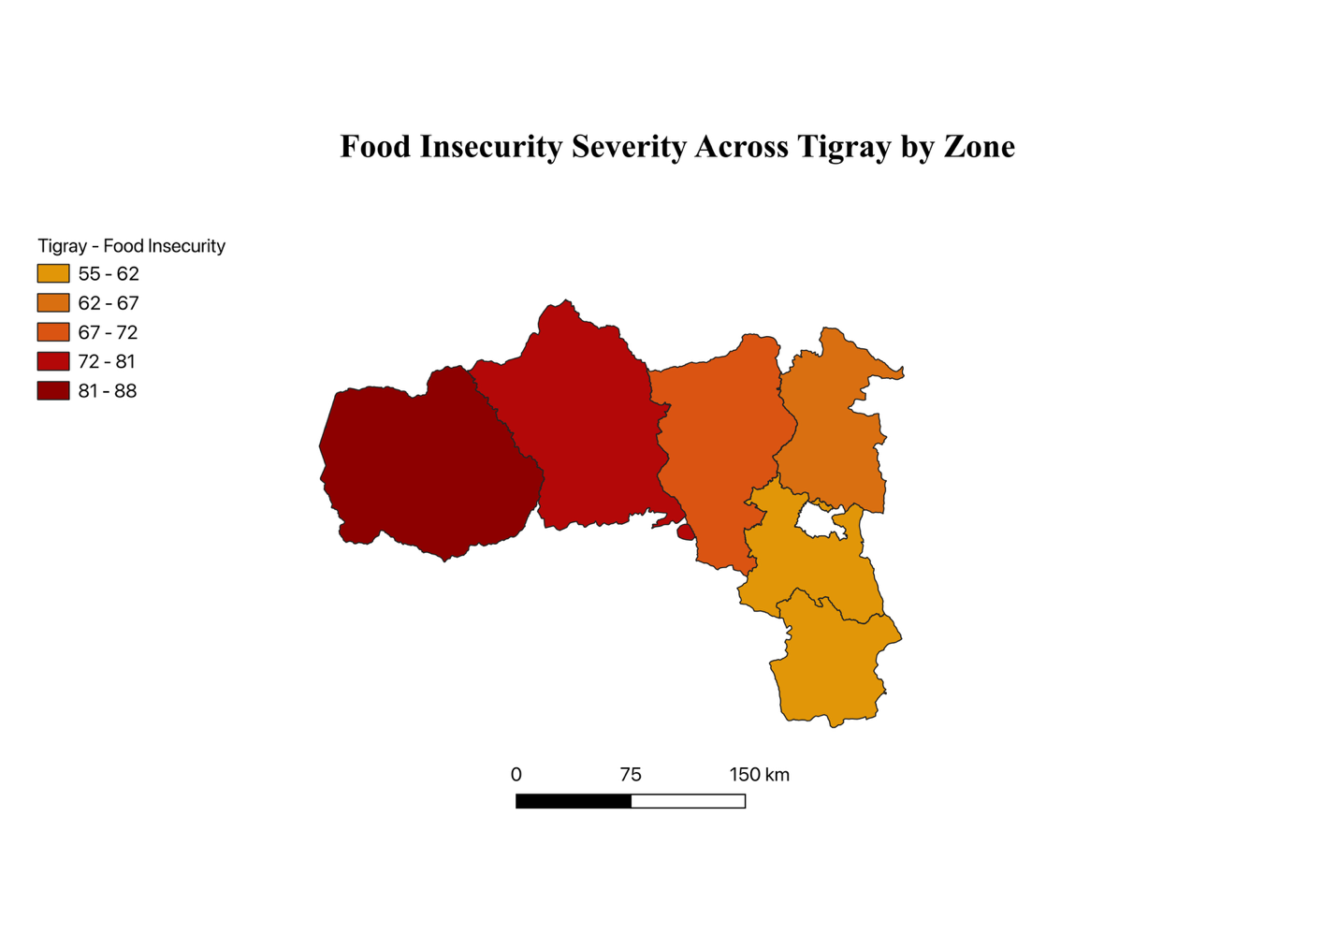
This map illustrates relative food insecurity severity across administrative zones in Tigray, based on humanitarian needs indicators aggregated at the zone level. The visualization highlights geographic variation in food access challenges during the crisis rather than precise household-level conditions.

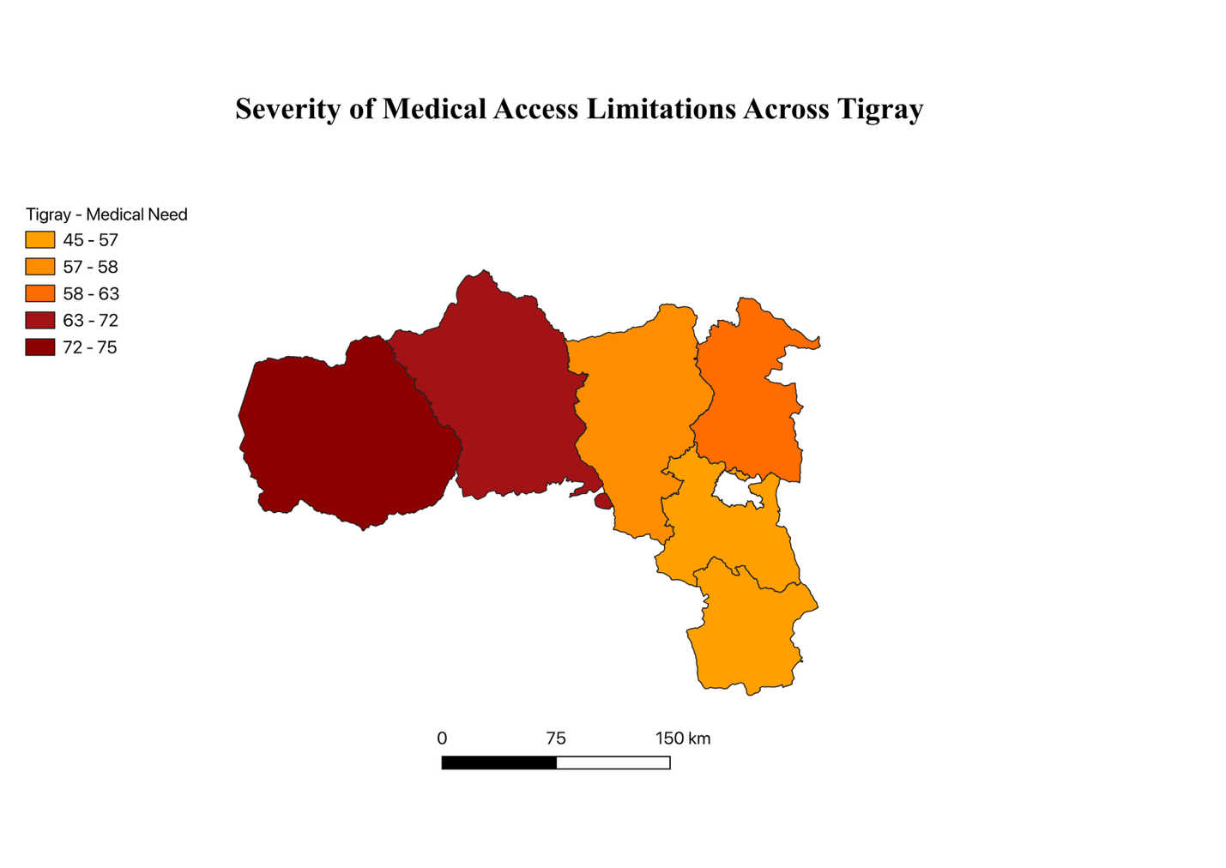
This map illustrates Medical Access Limitations severity across administrative zones in Tigray, based on humanitarian needs indicators aggregated at the zone level. The visualization highlights geographic variation in food access challenges during the crisis rather than precise household-level conditions.

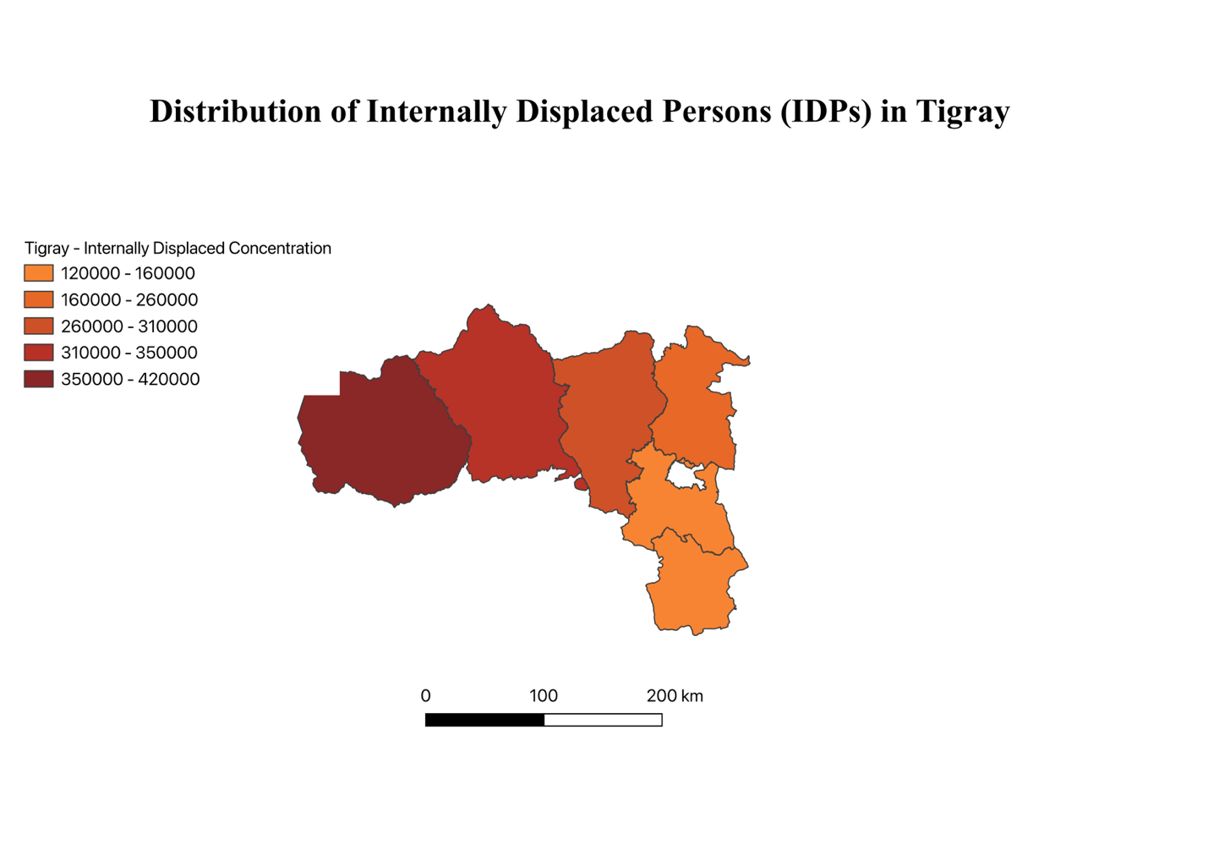
This map displays the reported distribution of internally displaced persons (IDPs) aggregated by administrative zone, highlighting the spatial concentration of displacement within Tigray. The visualization emphasizes relative displacement patterns rather than absolute population counts.

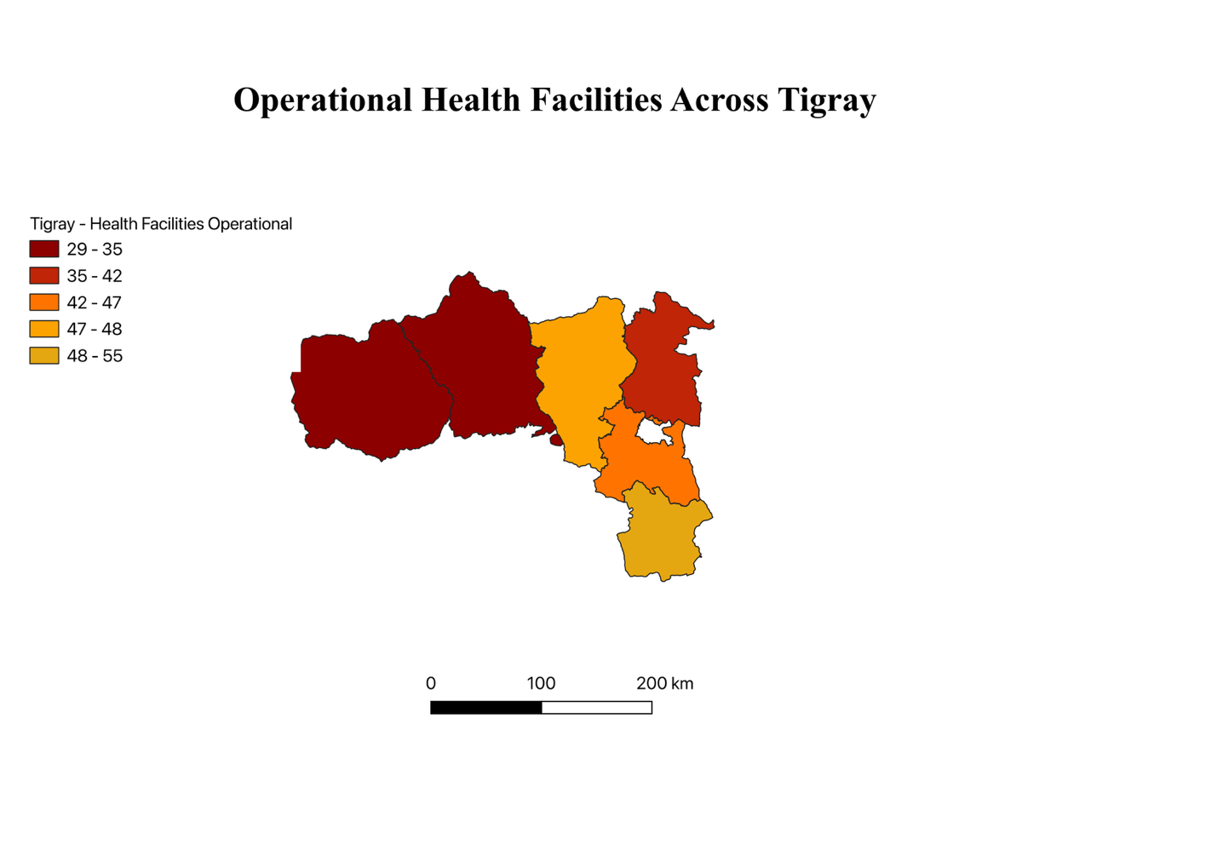
This map displays the reported distribution of Operational Health Facilities aggregated by administrative zone, highlighting the spatial concentration of displacement within Tigray. The visualization emphasizes relative displacement patterns rather than absolute population counts.

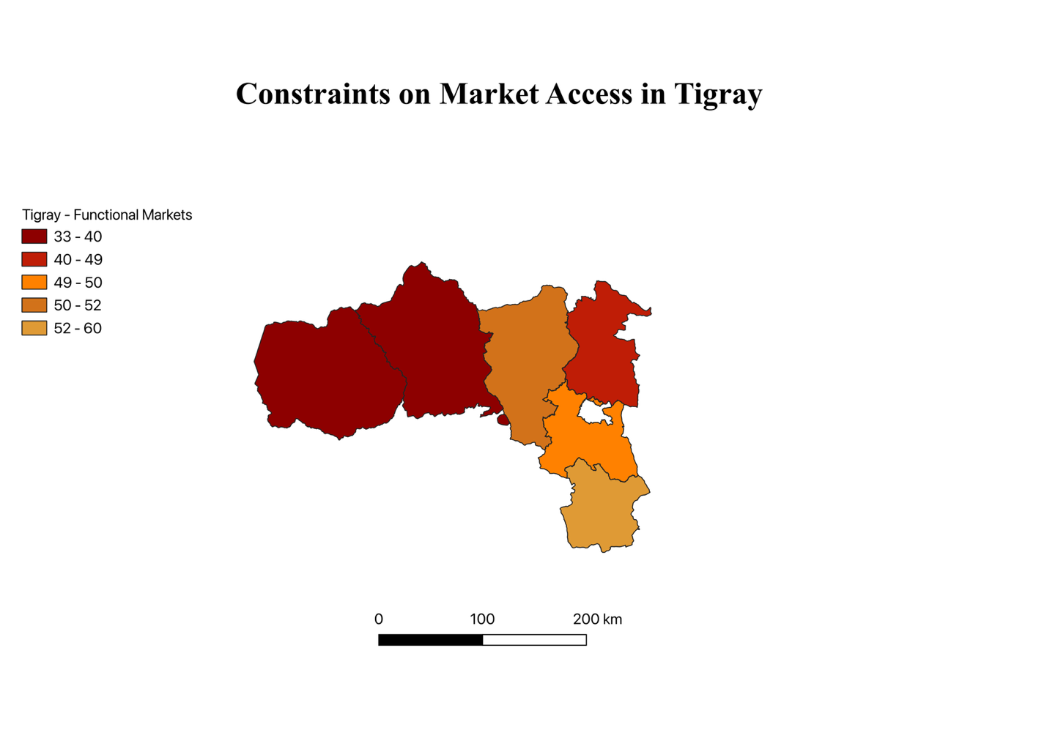
This map shows relative levels of market accessibility across administrative zones in Tigray, reflecting spatial variation in access to essential goods and services. The map represents reported accessibility conditions rather than real-time market functionality and stability.

*This map shows reported levels of market functionality across Tigray zones, indicating geographic variation in access to markets rather than real-time economic activity.*

The author has personal ties to Tigray; this analysis relies exclusively on independent humanitarian and human-rights reporting to mitigate bias.

